1. **Maintenance**
   1. **OS upgrades**

User need to maintain Device with iOS version 14.5 and above to install knee Balancer App. Check the latest OS upgrades from Apple and keep the OS up to date with latest OS upgrades.

* 1. **Minimum storage requirements**

Before use of the Knee balancer app the device should maintain at least 100mb free space for better performance.

* 1. **Knee Balancer upgrades**

Stryker app store provides the latest upgrades of the Knee Balancer app. Keep the MS intunes updated and signed in for the automatic updates of the latest Knee Balancer app upgrades

1. **Troubleshooting**
   1. **Auto Rotation**

The application always uses landscape mode for the proper view of the application. Whereas the camera capture uses portrait mode. The Knee balancer app guides user to use portrait mode if the phone is tilted landscape. Make sure the Auto Rotation feature is enabled in the settings.

* 1. **Settings of camera**

**Permission to use camera:** Very first time use of the camera Knee balancer app asks for the permission to use camera. Allow and proceed

**Leg Selection:** User needs to select the leg side (Right or Left) before capturing MAKO image. Compare the Fibula bone direction of MAKO image and the viewfinder of the knee balancer app before capturing the MAKO image.

If the wrong leg side of the MAKO image is captured return back, change the leg settings and then retake the image

**Generation:** User needs to select the input system (TKA1.0 or TKA2.0) before capturing MAKO image. Compare the color of the MAKO image is matching with the Knee Balancer initial position screen. The green implants represents TKA1.0 and Grey implants represents TKA2.0.

If the implants color is not matching return back change the input system and retake the image

* 1. **Ambiance settings while camera capture**

**Glare or brightness**: The camera should be position is such a way that there is no light or brightness is reflecting on the MAKO monitor

**Capturing Angulation and Resection:** Position the camera such a way that the camera view finder just covers 4 bones avoiding side images and external noise

**Capturing Gaps/ Laxities:** Position the camera such a way that the camera view finder just covers the 4 values avoiding side images and external noise

**Capturing HKA**: This needs to be entered manually

Note: The camera capture is 80-90 % accurate and may fail if any of the above conditions did not meet properly. in those condition retake the camera capture again or enter manually

* 1. **Case data Upload**

**Sign-in reminders**: Past case data should not be stored in the device for more than 30 days. Hence there is reminders to turn on internet and sign in before application gets locked

**Sign-in successful but still not able to upload case data**: Could be due to Unauthorized user access. Contact Stryker team for more details and get added into the user group.

1. **Decommissioning**

Decommission the Knee Balancer app in user mobile and remove azure blob storage permissions to user in cloud.

* 1. **Uninstall the app from the device**

Uninstall the Knee Balancer app in user device(iPhone) below are the steps to decommission the Knee Balancer app in user device(iPhone).

1. Open device and long press on knee balancer app and it will show Remove App pop-up like below and click on Remove App.

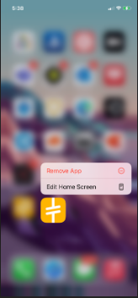

1. After click on Remove APP and it will show like below image and click on **Delete APP** thenapp will be deleted.

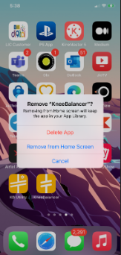

* 1. **Remove permissions from Azure Blob Storage Account.**

Revoke the user permissions from azure storage account. Contact Stryker admin team to revoke the permissions for user permissions in storage account. After user will not be able to upload the case details to cloud.